Transform Docs Application: Plant Disease Prediction and Detection

K.Geethika

K.Sweetha

K.Naga Kala

K.Nirmala4,c

Author Affiliations

1,2,3,4JNTU-GV COLLEGE OF ENGINEERING, VIZIANAGARAM

JAWAHARLAL NEHRU TECHNOLOGICAL UNIVERSITY- GURAJADA VIZIANAGARAM

DWARAPUDI, VIZIANAGARAM, ANDHRA PRADESH – 535003.

(A constituent college of JNTU-GV & Approved by AICTE ,New Delhi)(Recognised by UGC under section 2(f)&12(B) of UGC Act 1956)

Author Emails

kommanageethika@gmail.com

swethakonkyana05@gmail.comb

Kalkoppalli@gmail.comc

Nirmala.nirmala1237@gmail.comd

**Abstract:**

Plant diseases pose a significant risk to agriculture and food security. Traditional methods of disease identification are often time-consuming and require specialized expertise. This project leverages machine learning to automate the detection of plant diseases, which enables faster and more accessible diagnosis for farmers. The workflow includes data collection, preprocessing, feature extraction, model training, and testing, with the ultimate goal of using a trained model to classify new images accurately.

Convolutional Neural Networks (CNNs) are particularly suited for this task, given their ability to process and classify image data effectively. By implementing CNNs and other machine learning models, this project aims to enhance the precision and efficiency of plant disease identification, contributing to more proactive and sustainable agricultural practices.

1.**Introduction**:

Plant diseases are a major threat to global agriculture, leading to significant crop losses and affecting food security worldwide. Timely and accurate detection of these diseases is essential for effective disease management and prevention. However, traditional disease detection methods often rely on visual inspection by agricultural experts, which can be costly, time-consuming, and challenging to scale for large farms or regions with limited resources.

Plant disease prediction using machine learning offers a transformative approach to address these challenges. By analyzing images of plant leaves, machine learning algorithms, especially those based on deep learning, can identify disease symptoms early and with high accuracy. These models learn patterns associated with specific diseases, enabling them to differentiate between healthy and infected plants.

This project aims to develop an intelligent plant disease prediction system that leverages computer vision techniques to analyze plant leaf images. Using a labeled dataset of diseased and healthy plant leaves, the model will be trained to recognize various plant diseases automatically. The proposed system can serve as a valuable tool for farmers and agricultural practitioners, allowing them to monitor crops more effectively and take preventive actions to mitigate the spread of diseases.

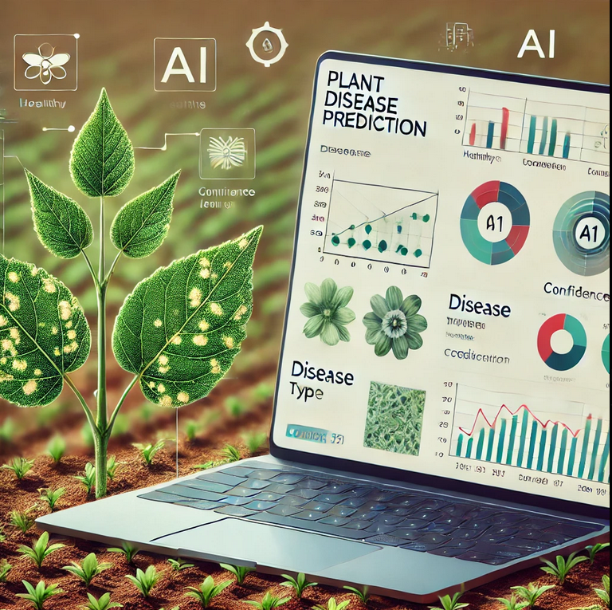

Workflow:

#### 1. **Identify File Type**

* This step determines the type of input data (e.g., image or CSV file containing image paths and labels) for the plant disease prediction model.
* **Image Files**: For image files (e.g., .jpg, .png), the workflow verifies that they are machine-readable, meaning the pixel data is accessible. If images are captured in a format incompatible with the model, such as unsupported image types or low resolution, pre-processing steps may be needed.

#### 2. **Image Pre-processing**

* **Objective**: Prepare the images for optimal performance in the machine learning model by improving quality and consistency.
* Pre-processing includes:
  + **Resizing**: Standardizing images to a fixed size that the model expects (e.g., 224x224 pixels for many CNN models).
  + **Normalization**: Scaling pixel values to a range, typically between 0 and 1, to maintain uniform data.
  + **Augmentation**: Applying random transformations (e.g., rotations, flips, color adjustments) to increase dataset diversity and enhance model generalization.

#### 3. **Feature Extraction Process**

* Extracting essential features from images to enable accurate disease classification. This process may differ based on the model used:
  + **Pre-trained CNN models** (e.g., ResNet, Inception) extract high-level features from images, capturing patterns like leaf shapes, color changes, and disease spots.
  + **Custom CNN models** may be trained from scratch to extract specific features associated with disease symptoms.

#### 4. **Model Training**

* **Objective**: Train a machine learning model using labeled data to classify plant diseases based on visual characteristics.
* Steps:
  + **Load Labeled Dataset**: Load images and their corresponding labels into the model.
  + **Training Process**: Train the model with supervised learning techniques, adjusting parameters to minimize loss.
  + **Validation**: Use a separate validation dataset to tune model performance and prevent overfitting.
  + **Evaluation Metrics**: Track accuracy, precision, recall, and F1 score to assess the model's effectiveness.

#### 5. **Prediction and Classification**

* The trained model classifies new input images, predicting the type of disease or identifying healthy plants.
* **Confidence Score**: For each prediction, the model provides a confidence level indicating the reliability of the prediction.

#### 6. **Post-processing and Output**

* **Objective**: Present the model’s predictions in a user-friendly format for easier interpretation and action.
* Steps:
  + **Generate Results**: Output predictions alongside confidence levels.
  + **Highlight Areas of Concern**: For images showing potential disease, highlight areas with symptoms.
  + **Report Generation**: Create a structured report summarizing disease prediction outcomes, ideal for practical use in the field.

**JSON Conversion**:

Plant disease prediction involves analyzing images of plants or data about the plants' health to identify potential diseases. This can be done using machine learning models, computer vision techniques, and data analysis methods. Here's an overview of how to approach plant disease prediction:

### 1. **Data Collection**

* Gather a dataset that includes images of plants with and without diseases. You can use publicly available datasets or collect your own from farms, gardens, or agricultural databases.
* The dataset should include multiple plant species and types of diseases (e.g., bacterial, fungal, viral).

### 2. **Image Preprocessing**

* Process the plant images by adjusting for lighting, resolution, and noise.
* Techniques like resizing, cropping, and color normalization can be used to standardize input data.

### 3. **Model Selection**

* **Convolutional Neural Networks (CNNs):** CNNs are highly effective for image classification tasks like plant disease detection.
* Transfer learning with pre-trained models like ResNet, VGG, or Inception can speed up model training by leveraging knowledge from other image recognition tasks.

### 4. **Model Training**

* Train the model on labeled images to recognize patterns associated with healthy plants and various diseases.
* Data augmentation techniques such as rotation, zoom, and flipping can help improve the model's generalization by artificially increasing the dataset size.

### 5. **Evaluation**

* Evaluate the model's performance using metrics like accuracy, precision, recall, and F1 score.
* Test the model on a separate test set to assess its ability to generalize to new, unseen plant images.

### 6. **Deployment**

* Deploy the trained model into an application, either as a standalone tool or integrated with an existing agricultural system.
* The application can take input images of plants, preprocess them, and use the trained model to predict whether a plant is diseased and identify the type of disease.

• **Dataset and Model Training**:

* Collect images of plants, and label them as healthy or diseased.
* Use a pre-trained CNN model like **ResNet** or **Inception** to train the model on these images.

• **Image Preprocessing**:

* Preprocess the plant images by resizing, normalizing, and augmenting the images.

• **Colorama for Output**:

* During the prediction process, use **Colorama** to highlight the key parts of the output in color for better visibility.

**9. Conclusion**

his OCR-based document processing project successfully automates the extraction and conversion of text from PDF and DOCX files into a machine-readable JSON format. By leveraging **EasyOCR** for text recognition and **Colorama** for user-friendly, color-coded terminal output, the script provides a seamless and efficient way to handle both text-based and image-based doc Integrating **Colorama** into a plant disease prediction script significantly enhances the user experience by providing visually distinct and easy-to-read feedback at various stages of the process. The use of color-coded messages—such as **green** for healthy plants, **red** for diseased plants, and **yellow** for processing—improves the clarity and accessibility of the results, making the system more intuitive and user-friendly. Additionally, **Colorama's cross-platform compatibility** ensures that the output remains consistent across different operating systems, making it a reliable tool for users worldwide.

This approach is particularly beneficial for users who are not familiar with technical details or for those in agricultural settings who need to make quick decisions based on plant health. The script becomes an effective tool not only for **automated disease detection** but also for **improving decision-making**, as the user can quickly understand the status of their crops through color-coded feedback.